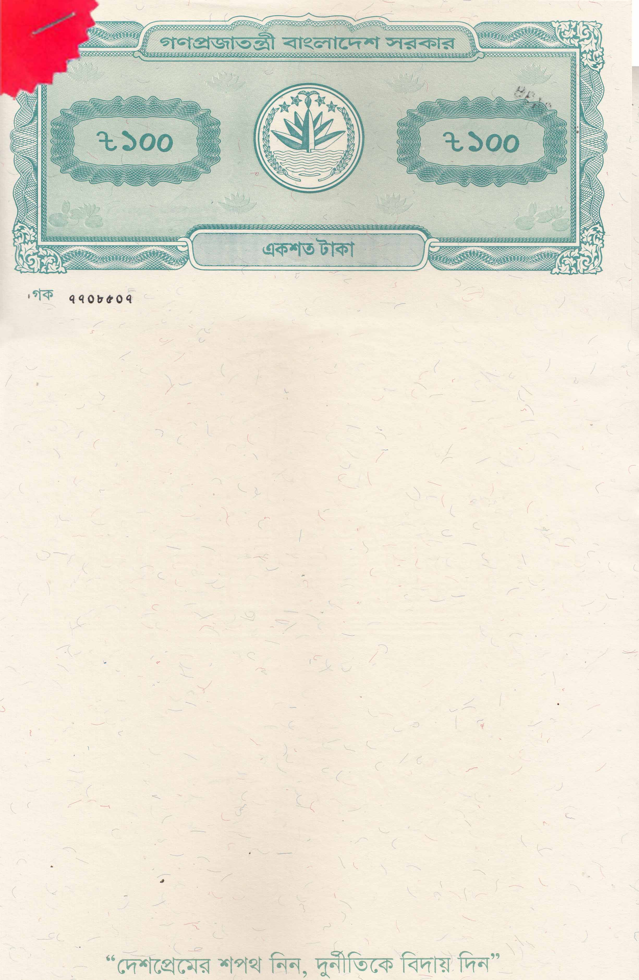

INVESTMENT AGREEMENT

This Investment Agreement (the "Agreement") is made and entered into at Dhaka on this the 29th Day of April 2024.
BETWEEN
MEHERUN NESSA, NID: 4194662419, Daughter of Md Ibrahim Pramanik & Zinnatun Nessa having address at 34,35,35/1, Shantinagar, Peer Sheb Er Goli, Paltan Model, Shantinagar-1217, Dhaka, Bangladesh (hereinafter referred to as 'First Party" which term shall unless repugnant to the context and contrary to the meaning thereof include its successors-in-interest legal representative, administrates and an assigns)
…………………….....ONE PART
AND
CARNIVAL CARE LIMITED, a company duly incorporated under the laws of Bangladesh, having its registered office at Uday Tower (Level 12), 57 & 57A. Gulsion Avenue, Gulshan-2. Dhaka, Bangladesh, represented by its Managing Director. Dr. Farshid Bhuiyan, (hereinafter referred to as ‘Second Party” and/or “Carnival Care”, which term shall unless repugnant to the context and contrary to the meaning thereof include its successors-in-interest legal representative, administrates and an assigns)
……………….......OTHER PART
(The participants of the Agreement are hereinafter collectively referred to as 'Parties' and individually as Party)
Whereas First Party wishes to invest fund in the business of Second Party under the terms and conditions mentioned in this Agreement.
NOW IT IS HEREBY AGREED as follows:
1. SCOPE
The Scope of this Agreement is to set the terms and conditions under which the First Party shall invest in Second Party.
2. TERMS & CONDITIONS:
- First Party invested BDT 59,00,000.00 (Taka Fifty-Nine Lacs Only), (the "Investment") to Second Party on 28 April 2024.
- Second Party will pay a return of 1.7% (One Point Seven Percent) per month ("Profit Return") to the First Party until the repayment of the Investment by Second Party to the First Party.
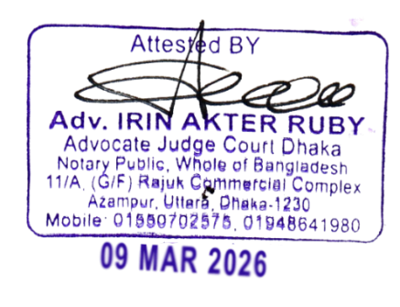
- The first payment on the investment will be made on 1 week of June 2024. After that, Profit payment will be made within 7% working day of each month on the Investment Amount for the entire period.
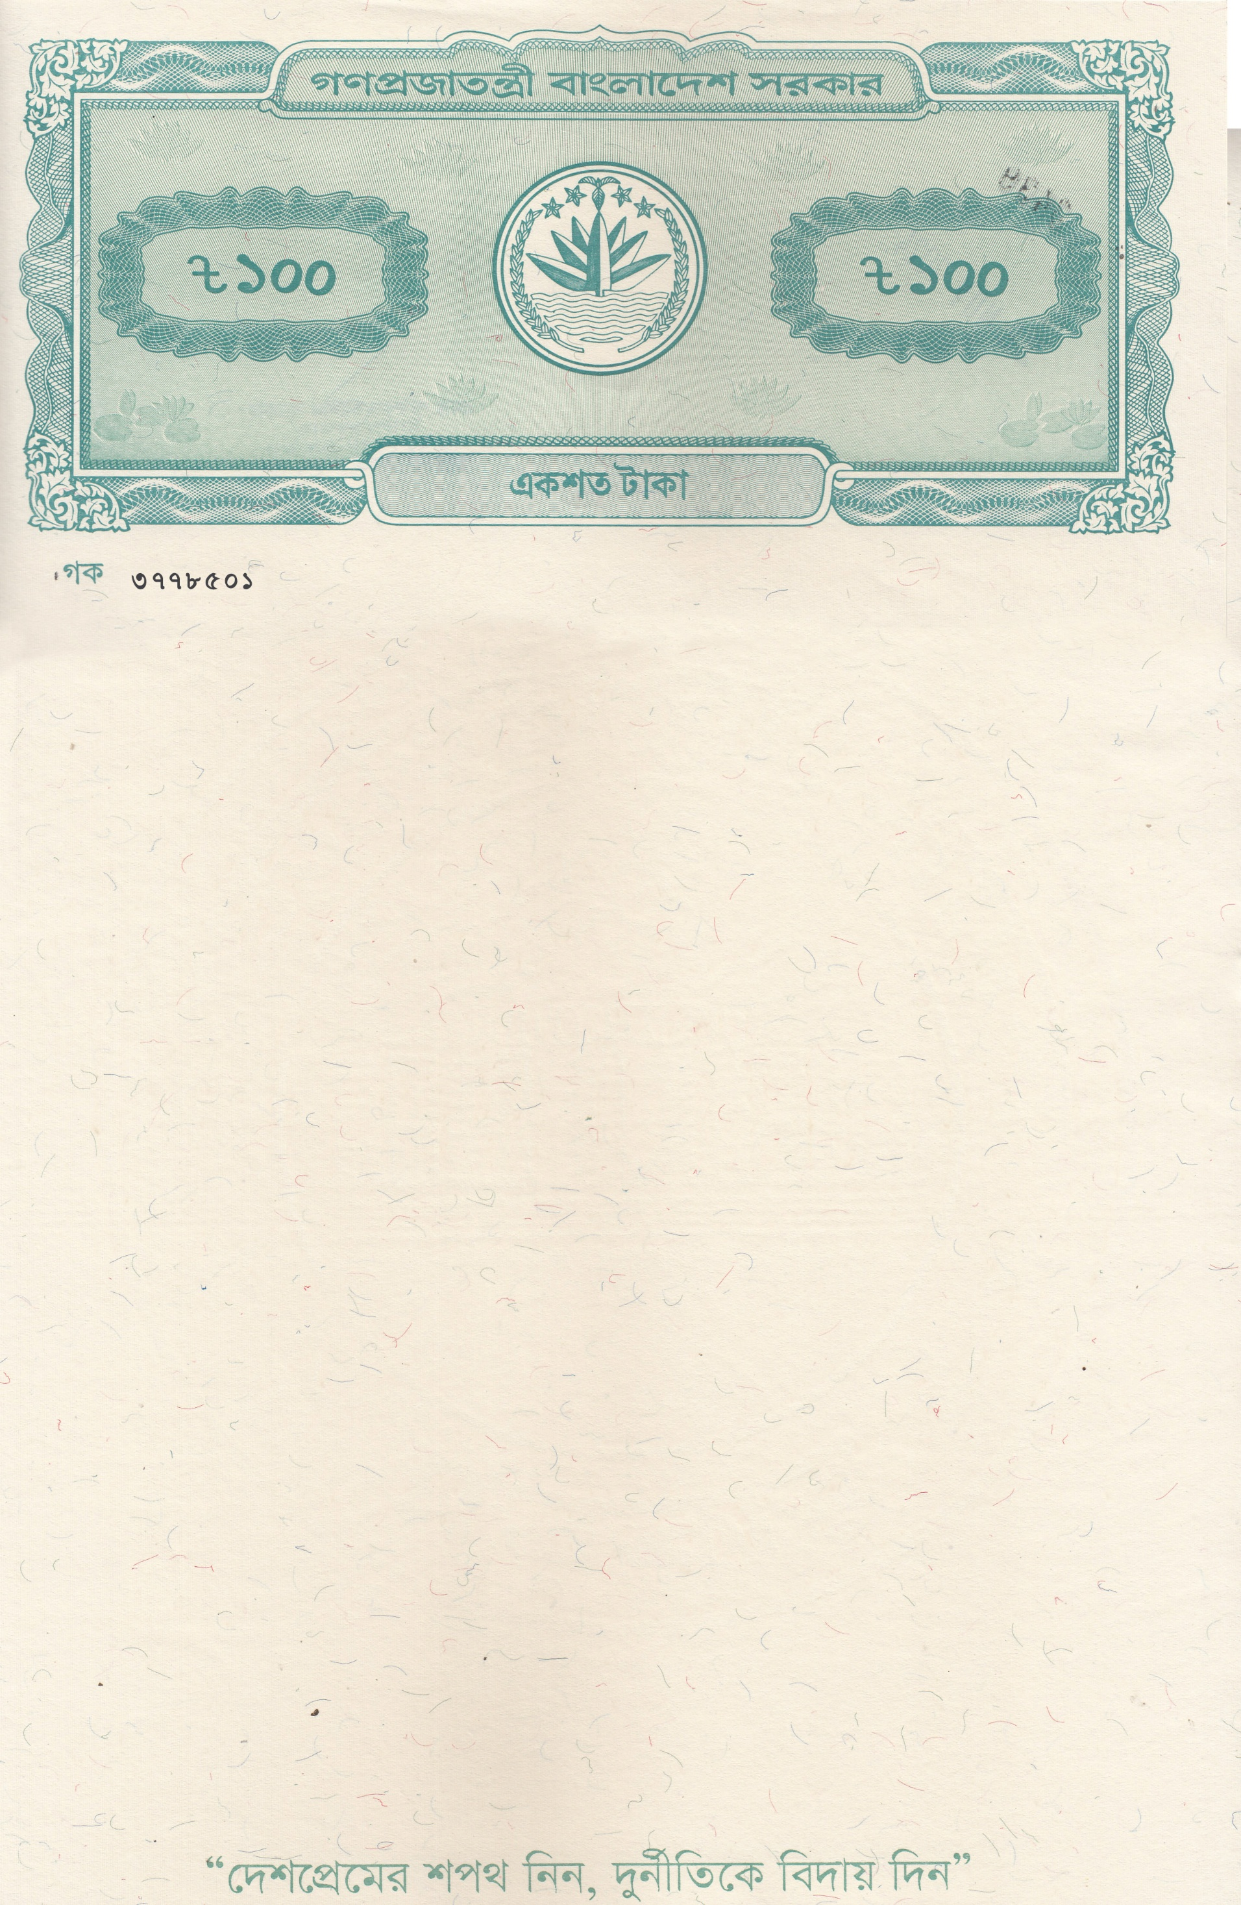

Page-02
3. WITHDRAWAL/ADJUSTMENT
- The investment will be for 2 years. During this period the Profit Return will remain the same. After the completion of 2 years if both parties agree to continue then the Profit rate may be changed.
- Second Party will not adjust or First Party will not withdraw the Investment amount for at least 12 (twelve) months.
- After 12 months each party may make partial or full adjustment/withdrawal of the Investment by giving 3 (three) months' notice to the other party.
- In case of partial withdrawal of the Investment amount, Second Party will pay the Profit to First Party on pro-rata basis of the remaining Investment amount.
4. TERMINATION
- Each Party may terminate this Agreement by giving 3 (Three) months' notice to the other after completion of 12 months from the date of Investment.
- At the end of the notice period Second Party will pay the Investment amount back to First Party.
- Repayment of the Investment amount by Second Party will be considered as termination of the Agreement.
5. DISPUTE RESOLUTION
It is hereby agreed that the dispute will be resolved amicably between the Parties. However, if the Parties are unable to resolve the dispute amicably within 15 (Fifteen) days from either Party's notice of dispute, the same shall be referred to in arbitration and finally settled in accordance with Arbitration Act, 2001 of Bangladesh. The place of arbitration shall be Dhaka, Bangladesh and each Party shall nominate his respective arbitrator and arbitrators will select the umpire of the tribunal. The arbitral award shall be binding for both Parties.
6. GOVERNING LAW
The Agreement shall be governed by and construed in accordance with the laws of Bangladesh and shall be subject to the jurisdiction of the court of Bangladesh



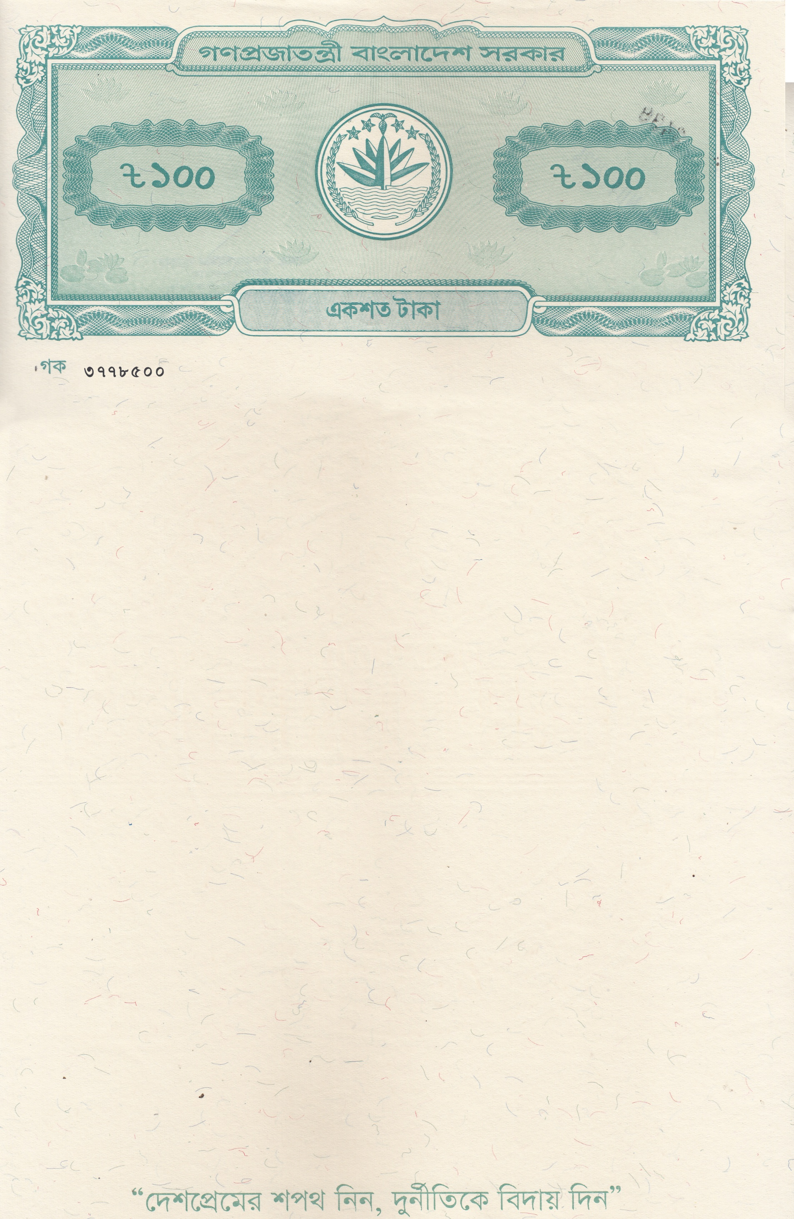
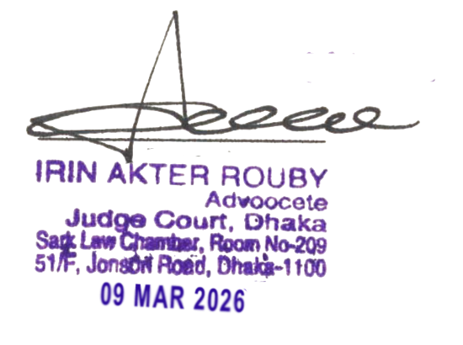


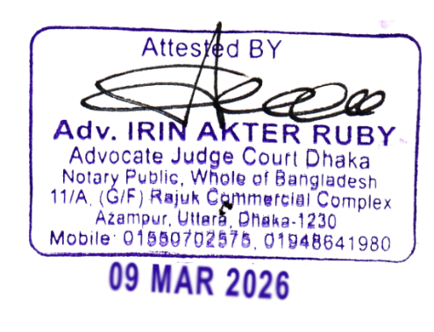

Page-03
This Agreement is made in 2 (two) sets in original. Each of the parties shall get a set of original of the Agreement
IN WITNESS WHEREOF, the Parties hereto have executed and delivered this Agreement as on the date first above written. The following signatories are duly authorized by the respective Party to this Agreement to represent the Parties.
For and on behalf of: For and on behalf of:
MEHERUN NESSA CARNIVAL CARE LIMITED

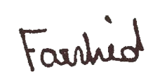
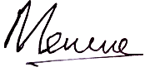

MEHERUN NESSA Farshid Bhuiyan
Managing Director

Witness: Witness:

